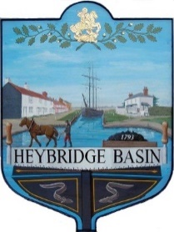
HEYBRIDGE BASIN PARISH COUNCIL
Memorial Plaque Application Form

Applicants Details:

Mr/Mrs/Miss/Ms/Other  Please indicate |  | Surname: |  |  |  | First Name/s:
Address: |  | Postcode:
Telephone: |  |  |  |  |  | Email:
Signature of owner: |  |  |  |  |  | I agree to the terms stated within the Memorial Policy regarding additional memorabilia and removal of the plaque if required. |  | Date:
For Official Use Only

Plaque No. |  |  | Payment Received:  (Date) |  | Plaque Approved/Ordered:  (Date) |  |  |  | Plaque Fixed:  (Date)

INSCRIPTION INFORMATION:
Please complete the information below clearly and using BLOCK CAPITALS.
Please check that you have checked carefully your inscription below, as a mistake cannot be altered afterwards. The Parish Council reserves the right to refuse wording which is considered unsuitable.
Name of Deceased:
Address of Deceased: | Postcode:
Year of Birth to Year of Death:
Inscription:
The cost, which includes plaque and installation by Heybridge Basin Parish Council will be sent to the applicant in writing once the Council has approved and confirmed the Inscription information.

The Plaque will be ordered once the Council confirms receipt of payment.

Payments are accepted via BACS to:
Heybridge Basin Parish Council
Account Number: 20424394
Sort Code: 60-83-01

Cheque made payable to: - Heybridge Basin Parish Council and posted to the address below.

Please return your completed form to the Parish Clerk via post or email to:
HBPC, PO Box 13224, Maldon, CM9 9FW Clerk@heybridgebasinpc.org.uk

